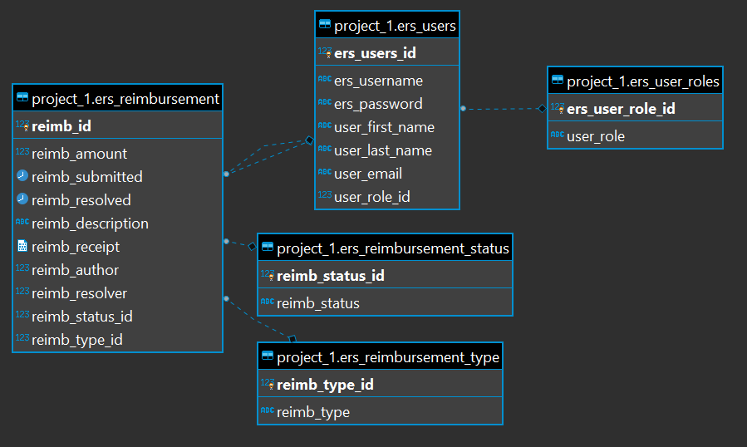

API design

Login:

GET/users, user_roles – retrieves users and roles for login and available functions.

Functions:

Employees:

GET/tickets – retrieves all previous ticket requests.  
 POST/new_ticket – adds new ticket for manager’s consideration.  
 PATCH/new_ticket – make changes to current request.

Managers:

GET/tickets – retrieves all tickets from all employees.  
 GET/tickets, status, type – retrieves all tickets of a certain status or type.  
 UPDATE/ticket, status – changes ticket status to approve/deny.